IBACH Data Access Guidelines
Thank you for considering the use of IBACH data to support your research endeavors. Using data from studies conducted at IBACH means that you have the opportunity and responsibility to share your results with others. This sharing process can take many forms – theses, dissertations, academic and community presentations, press releases, reports, and manuscripts. For the purpose of this document, we use the term “product” to refer to any and all forms of dissemination.

Please note that several IBACH studies require additional or different approval processes. These studies (effective October 2014) include the Hispanic Community Health Study/ Study of Latinos (HCHS/SOL) and its ancillary studies, the Peers for Progress (PfP) Puentes study, and the Childhood Obesity Research Demonstration (CORD) study Our Choice. Please contact the respective Project Manager (PM; or designee) and Principal Investigator (PI) for more information on the approval processes for these studies (see IBACH website for names and contact information).

Data Access Approval Process
- Before proposing a topic, you should request the following documentation relevant to the study from the PM (or designee):
  - Study Codebook (response categories for each variable, frequencies of all raw variables)
  - Study Derived Variable Dictionary (frequencies of all derived variables)
  - Study Methods Description (1-2 page description of study)
  - Study data collection instruments (surveys, interview guides, observations, and other forms)
  - Study Product Tracking document of published and in progress products (list of manuscripts, presentations, theses, and dissertations completed or in progress so you don’t propose an idea that has already been examined or is currently being studied)
  - IBACH Data Access Guidelines (this document)

Note that not all studies will have all of these documents ready at the time of your request. Please respect study timelines and minimize the number of different times you need to ask questions during this process. Read these guidelines carefully and be prepared with as many questions as possible. If documents are not available, ask the PM (or designee) for best next steps.

- To access data, a Data Access Request Form (see below) must be submitted to the PM and PI. Prior to submission of the completed form, you should propose the research question to the study team, including the PI, to make an initial confirmation of no overlap with other published products or products in progress; note that you should have already confirmed that no such question has been asked by examining the Study Product Tracking document. If you are a student, please consult with your undergraduate, masters or doctoral advisor (herein referred to as advisor) to ensure that it is an appropriate research question for your intended purpose(s).

  - If you are concerned that the sample size may not be large enough to answer your research question or there isn’t enough variability in your outcome variable, check the study’s Codebook and Derived Variable Dictionary (if available) and consult with your advisor or biostatistician. If the request is to analyze a specific subsample (e.g., if you wish to only look at men with hypertension in a database that includes both genders and non-hypertensive individuals), check with the PM (and/or designee) to run frequencies on the primary outcome to determine if the research question is feasible to examine.

- Once you have determined the proposed research question does not overlap with any other products and there is sufficient sample size and variability to conduct analyses, you will submit a Data Access Request Form (see below) to the PM (and/or designee). If you are a student, the form must first be reviewed and approved by your advisor.
  - Please review the Data Access Request Form for completeness of each section and variables requested before submission. If incomplete, it will be returned without edits until all sections are complete.

- Once the Data Access Request Form is approved by the PM (and/or designee), it is forwarded for review by the PI and Co-Investigators affiliated with the study. Unless there are special circumstances such as an unexpected deadline, investigators are given two weeks to read and approve/deny the request.

- Three possible decisions will be made by the investigators. The PM (and/or designee) will contact you and inform you of the next steps. The following are the actions to be taken upon receiving the decision:

  - Approved
      - Contact all potential co-authors from among the investigative team (investigators, staff, students involved) and establish a formal working group.
      - Set up meetings according to your timeline included in the Data Access Request Form.
      - Establish the final list and order of authorship.
        - The PI is included in all papers affiliated with his/her studies. Be sure to contact the PI to determine which author position he/she feels is appropriate for this product.

  - Minor Revisions: Approved with modifications required, for example, identifying additional co-authors, suggesting changes to variables used, revising timeline, etc.
      - Make suggested modifications and send revised version for review by the PM (and/or designee).
      - To ensure that your request flows through quickly and efficiently, you are encouraged to get your request back to the PM within two weeks to one month of receiving the revisions.
      - Once approved by the PM, the revised request will be resubmitted to the PI and Co-Investigators for approval. As before, investigators are given two weeks to respond; however, usually at this stage and with only minor revisions, turn-around can be as fast as 48 hours.

  - Major Revisions: Major changes required before you can proceed. This could include concerns with possible overlap with other products in progress or completed.
      - Make revisions as required, including possible changes in outcome variables.
      - Resubmit Data Access Request Form to the PM (and/or designee) to resume the approval process, starting at step 4 above.

- Once approved, the PM (and/or designee) will use the approved Data Access Request Form to request a modification to the project’s IRB on your behalf. Note: for students, this step is mandatory.

  - If a dataset is still open (data collection is still occurring, the study is still in progress), a modification will be submitted by the PM to IRB to add you to those who have access to the data. Co-investigators, and staff members included in original IRB protocol do not need a modification submitted on their behalf. Please allow at least one to two months for this process. A dataset cannot be released without IRB approval.

  - If a dataset is closed, the PM does not need to submit an IRB modification; however, you must submit an independent IRB protocol to SDSU (or your institution if not SDSU) in order to receive a dataset (see sample IRB modification). Once you receive IRB approval, submit this approval to the PM (and/or designee) to receive the dataset.

- Once IRB approval is received, a dataset will be prepared for you. Depending on study priorities, this can take between one to two weeks. The analysis dataset that you receive will be cleaned and recoded and will only include variables that you requested. For certain variables, only recoded variables will be provided unless a request is made for raw variables (see the Derived Variable Dictionary for how variables are coded and scores calculated). As described above, the following documents related to the dataset and the study will be made available to you to assist you in understanding the dataset and the study. These documents will facilitate the preparation of your product.

    - Codebook (frequencies of all raw variables)
      - This document contains the frequencies/descriptive statistics of all variables in the dataset. For categorical variables, frequencies will be provided and for continuous variables, mean, standard deviations, and range of values will be provided. For the string variables, the number of unique responses will be provided.

    - Derived Variable Dictionary (frequencies of all coded variables)
      - This document contains the frequencies of derived variables (e.g. computed depression scores, calculated BMI, etc.). In addition, derived variables/scale description, interview setting and mode of administration, reference related to the derived variable/scale, data processing and editing, and analytic notes are included.

    - Data collection instruments including surveys, interview guides, observations, and other data collection forms.

    - Methods documentation includes the following:
      - Participant eligibility (inclusion/exclusion criteria) and sample size
      - Study setting
      - Study design
      - Intervention staff training (if applicable)
      - Intervention description (if applicable)
      - Participant enrollment
      - Consort table
      - Evaluation protocols
      - Funding agency acknowledgement

- In the methods section of your product, you must include a description of how variables were re-coded or computed and how analyses were completed.

Ensuring Quality Control
- Although databases are cleaned and prepared prior to distribution, errors are inevitably missed. Therefore, as you begin to work with the data, you are advised to run descriptive statistics (frequencies, means, standard deviations, minimums, maximums, cross tabulations between variables, etc.) on all variables you intend to use. (See Appendix)

  - If you find errors (e.g., invalid responses such as a value of “8” on a scale that only includes values from 1-5), you should generate a list of errors and submit the list to the PM (and/or designee) after all of your initial data cleaning is completed. Please include the ID number, variable name, and erroneous value in this document. The PM (and/or designee) will help resolve errors.
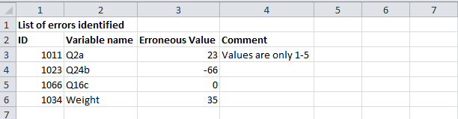

  - If a case is excluded from the analyses because a value for a specific variable is an outlier or represents some other irregularity or is missing key variables, you should document this and report this in your error list to the PM (and/or designee) or in the methods section of your product (if appropriate).

- Once you have completed your analyses and your product, submit the following to the PM (and/or designee) alongside your product (text and tables/figures) so that your results can be checked by the data manager. Please make sure to remove all extraneous notes on these documents. He/she will review these materials and determine if any changes are needed and will communicate this to you. You will be notified if the materials are not submitted in the appropriate fashion. (Note that if utilizing a statistical package other than SPSS or SAS, you may need to ask one of your co-authors to check your results. Consult with the PM (and/or designee) first. )

  - Please provide the following in a complete syntax file:

      - Section 1: Add comment in the syntax file that indicates any cases or values excluded as explained in 1b above. (See Figure 1).

      - Section 2: All syntax for recoded, relabeled, or computed variables by domain or topic. (See Figure 2).

      - Section 3: Syntax separated by corresponding table or figure in the product. (See Figure 3).

      - Section 4: Syntax for any analyses reported in the text and not in a table or figure. (See Figure 4).

(Note: Make sure that syntax includes variable and value labels).

- Your syntax will be used to run your analyses in the original dataset provided by the PM (and/or designee), so be sure that it is complete, accurate, and flows from your recoding syntax.

  - If your syntax does not run on the original dataset, it will be returned and you will be asked to revise your syntax and description to include all completed steps.

Figure 1. Section 1: Outliers and Exclusions
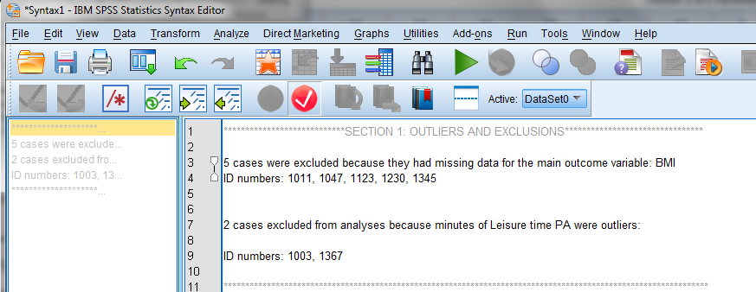

Figure 2. Section 2: Syntax for recoded or computed variables by domain or topic.
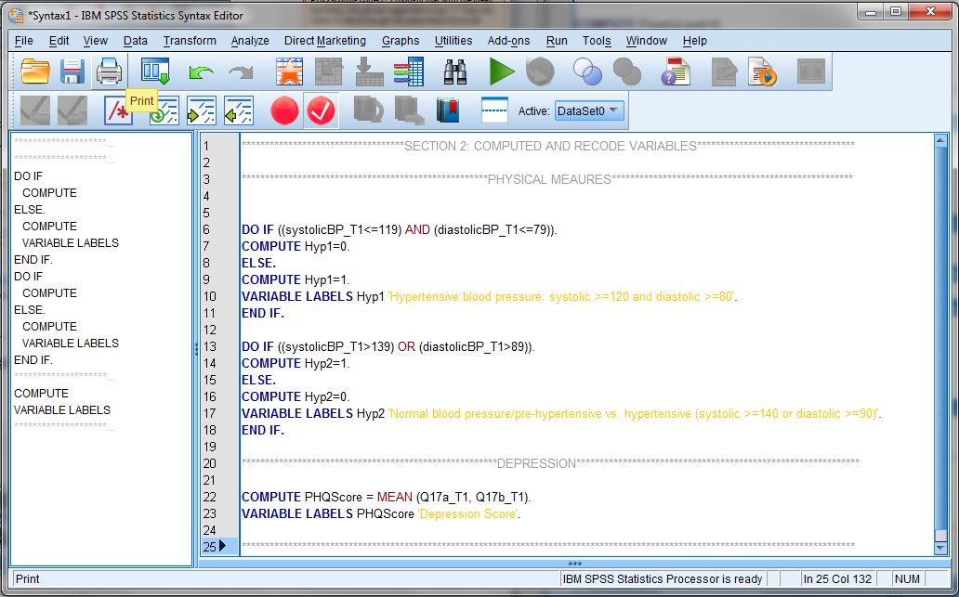

Figure 3. Section 3: Syntax separated by corresponding table or figure in the product.

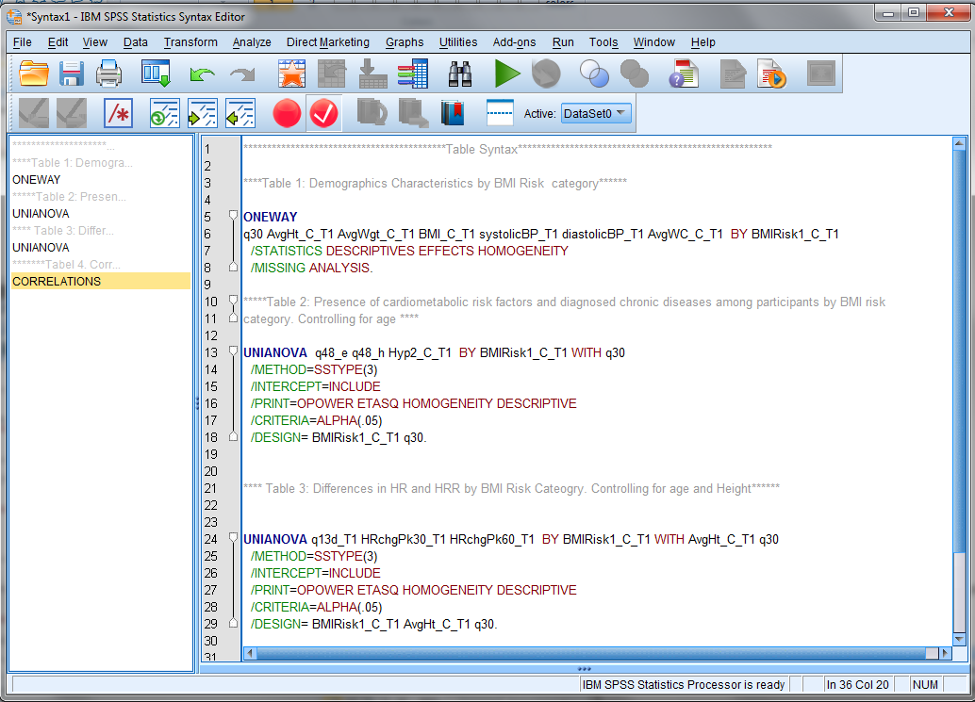

Figure 4. Section 4: Syntax for any analyses reported in the text and not in a table or figure.

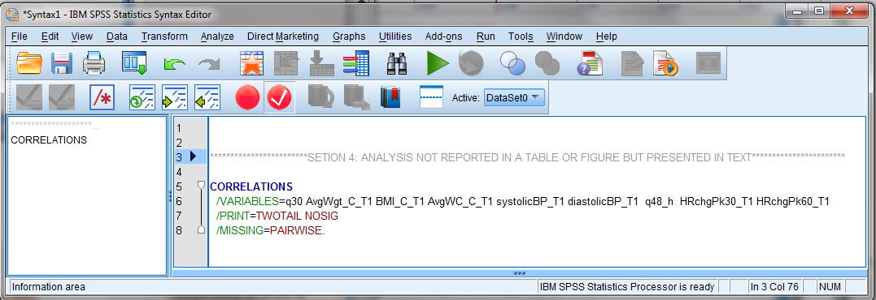

Submitting the Final Product
      - A minimum of two weeks should be allotted for checking the syntax and final approval by co-authors, PI and PM (and/or designee).
        - If the product is a master’s thesis or dissertation, then the product should be approved by the student’s committee prior to submitting for approval to the study investigators.
      - Products should not be submitted to the conference website or journal until approval from those identified in the above step.
      - Final accepted or under review versions of products must be submitted to the PM (and/or designee) for archiving and to all co-authors, including the PI for their files. You are encouraged to also submit the reference for the co-authors’ respective CVs and the product list maintained by the PM (and/or designee). Send citation using APA format.

Example:
Elder, J.P., Ayala, G.X., Arredondo, E., Talavera, G.A., McKenzie, T., Hoffman, L., Cuestas, L., Molina, M., & Patrick, K. (under review) Community health partnerships for chronic disease prevention among Latinos: The San Diego Prevention Research Center. Journal of Primary Prevention.

For peer reviewed journals, publications, presentations or poster presentations:
Add acknowledgements section and grant number to the product. For most studies, it is necessary to acknowledge individuals, coalitions or agencies that were key to the development and implementation of the study. All manuscripts must acknowledge the funding agency and should use the number and wording provided in the Methods Description document given to you by the PM (and/or designee).

Post Manuscript Submission Changes
If the reviewers of your product require adding/modifying the analyses, or analyses are changed to submit to a new journal/conference, syntax and new tables/figures must be resubmitted to the PM (and/or designee) and co-authors again for review. Complete step 2 under ‘Ensuring Quality Control’ section. Please allow the designated person two weeks to review the syntax/analyses.

Additional guidelines for publication in a peer-reviewed journal
Responsibilities of Lead Author
- Identification of a lead author is based on the person’s interest, willingness to do the work, and time available to complete the work.
- The lead author must prepare a request to use IBACH data and submit it to the PM (and/or designee) as outlined above.
- Upon submission to the journal, the lead author will forward the confirmation and product to the PM (and/or designee) for archiving and co-authors for their files.
  - Manuscripts that require revisions and resubmissions must also be submitted. Please make sure to adhere to journal guidelines and obtain permission to resubmit from your co-authors.
  - If rejected and submitted to a different journal, these must also be submitted for review and approval. Also resend the new reference for the product list to the PM (and/or designee) and co-authors.
- Once the manuscript is published, a type-set copy of the product is sent to the PM (and/or designee) for archiving and to the co-authors for their files.

Criteria for Authorship
Invitations to participate as an author for a manuscript should include individuals whose original ideas were critical to the implementation of the related study component or who are well-suited to offer suggestions for documenting the related project experience.

Working on an IBACH project does not constitute automatic authorship. All authors must make substantial contributions such as:
- Conceptualization and design or analysis and interpretation of the data
- Drafting the manuscript or editing it critically for important content

Individuals who have less experience writing a peer-reviewed manuscript or preparing a presentation for a professional conference may qualify as authors if, either individually with the lead author or with the entire writing group, they:
- Are involved in decision-making related to the study conceptualization, design, implementation, and/or evaluation;
- Are involved in discussions about the interpretation and write-up of findings;
- Review and approve the final version.

Once established, new authors should not be invited without written approval from the PI. If the lead author does not complete the activities within the time proposed, the PM (and/or designee) and PI will determine the next appropriate steps. Authorship order may be modified at pre-publication stage if changes are necessary to reflect the actual work contributed.

Additional authorship guidelines can be found on the APA and APHA websites. Please also know that many journals will require the first author to list out the role of each author in the study, including preparation of the manuscript, so careful thought to authorship is warranted.

Authorship Order
In most cases, the lead author will become the first author. However, the PI can modify authorship order if the responsibility and workload changes from the inception of the manuscript. The lead author is ultimately accountable for any information presented in the manuscript and will propose the author list and order to the PI for discussion and approval based on contributions to the final product.

Acknowledgments
Acknowledge funding agency by adding the grant number to the product. You may also consider acknowledging individuals, coalitions or agencies, study participants that were key to the development and implementation of the study.

[Would you like to see a sample data access request? Visit our website at www.ibachsd.org]

Appendix A.

Sample syntax for running frequencies, descriptive statistics and normality plots.
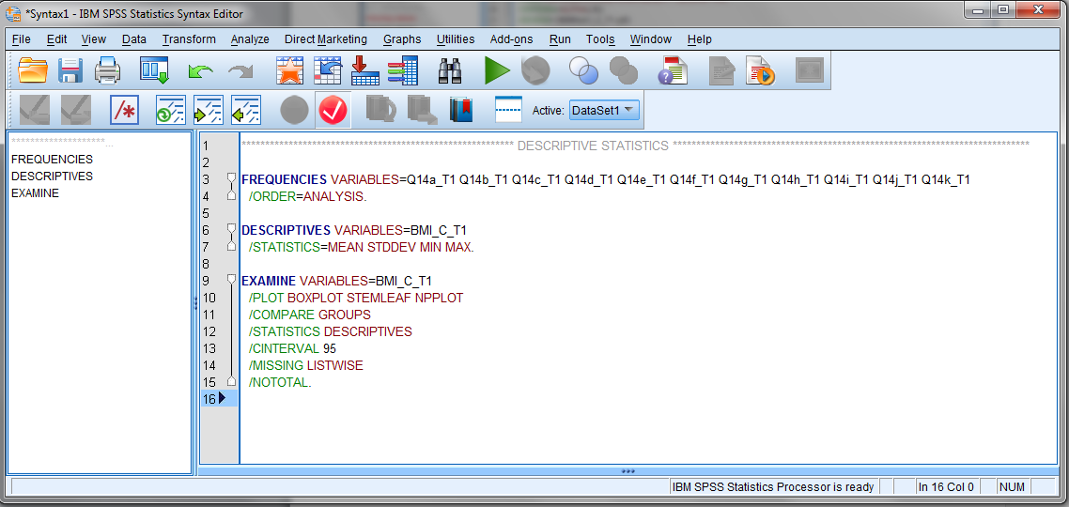

Sample Frequency Output
Q14b_T1 Barriers of PA: being too lazy.
 |  | Frequency | Percent | Valid Percent | Cumulative Percent
Valid | 1 Strongly Disagree | 104 | 31.4 | 31.4 | 31.4
Valid | 2 Disagree | 65 | 19.6 | 19.6 | 51.1
Valid | 3 Neither | 51 | 15.4 | 15.4 | 66.5
Valid | 4 Agree | 76 | 23.0 | 23.0 | 89.4
Valid | 5 Strongly Agree | 35 | 10.6 | 10.6 | 100.0
Valid | Total | 331 | 100.0 | 100.0

Sample Descriptive Statistics Output
Descriptive Statistics
 | N | Minimum | Maximum | Mean | Std. Deviation
BMI_C_T1 Body Mass Index at Timepoint 1 | 331 | 16.67 | 62.47 | 30.0474 | 6.22384
Valid N (listwise) | 331

Sample Normality Output
Case Processing Summary
 | Cases
 | Valid |  | Missing |  | Total
 | N | Percent | N | Percent | N | Percent
BMI_C_T1 | 337 | 100.0% | 0 | 0.0% | 337 | 100.0%

Descriptives
 |  |  | Statistic | Std. Error
BMI_C_T1 | Mean |  | 30.3921 | .35933
BMI_C_T1 | 95% Confidence Interval for Mean | Lower Bound | 29.6852
BMI_C_T1 | 95% Confidence Interval for Mean | Upper Bound | 31.0989
BMI_C_T1 | 5% Trimmed Mean |  | 29.8769
BMI_C_T1 | Median |  | 29.4391
BMI_C_T1 | Variance |  | 43.513
BMI_C_T1 | Std. Deviation |  | 6.59642
BMI_C_T1 | Minimum |  | 16.67
BMI_C_T1 | Maximum |  | 62.47
BMI_C_T1 | Range |  | 45.80
BMI_C_T1 | Interquartile Range |  | 7.48
BMI_C_T1 | Skewness |  | 1.488 | .133
BMI_C_T1 | Kurtosis |  | 3.870 | .265

Tests of Normality
 | Kolmogorov-Smirnovª |  |  | Shapiro-Wilk
 | Statistic | df | Sig. | Statistic | df | Sig.
BMI_C_T1 | .100 | 337 | .000 | .906 | 337 | .000
a. Lilliefors Significance Correction

BMI_C_T1

BMI_C_T1 Stem-and-Leaf Plot

Frequency Stem & Leaf

1.00 1 . 6
3.00 1 . 899
13.00 2 . 0001111111111
22.00 2 . 2222333333333333333333
49.00 2 . 4444444444444444444445555555555555555555555555555
49.00 2 . 6666666666666666666666666777777777777777777777777
46.00 2 . 8888888888888888888899999999999999999999999999
50.00 3 . 00000000000000000000000000011111111111111111111111
28.00 3 . 2222222233333333333333333333
29.00 3 . 44444444444444555555555555555
12.00 3 . 666666677777
12.00 3 . 888888889999
4.00 4 . 0011
4.00 4 . 2233
2.00 4 . 44
13.00 Extremes (>=45)

Stem width: 10.00
Each leaf: 1 case(s)

